How to save and recreate an analytics report using the xml of the analysis | 

Yoel Kortick
Senior Librarian

This document will show how to how to save and recreate an analytics report using the xml of the analysis.
This may be useful, for example,

- To share a report with another user who does not have access to your catalog or a shared directory
- As a method of backing up a version of a report

ONE
Click "edit" on the report you want to save or share and then switch to the "advanced" tab.

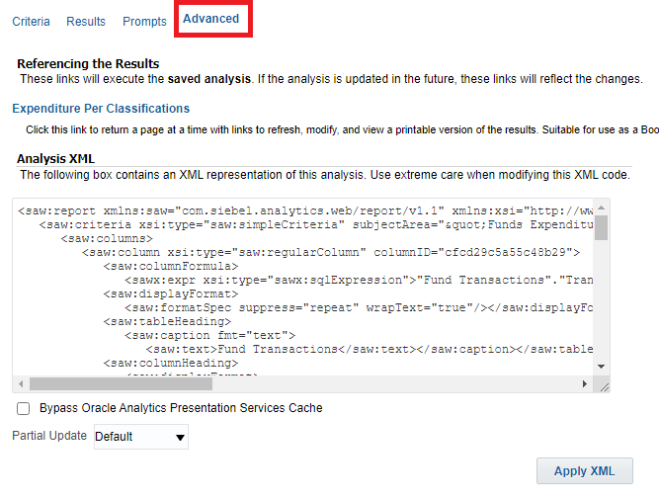

TWO
Copy the xml from the “Analysis XML” section and paste to a file for example in “notepad” and save with suffix .xml

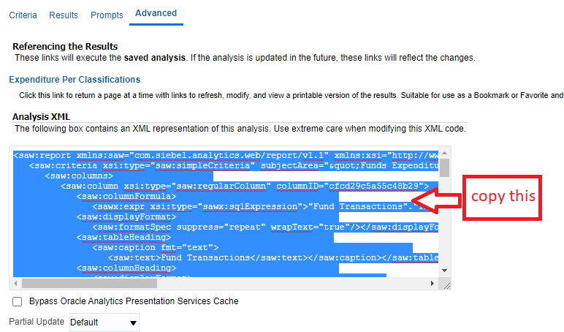

Save to an xml file

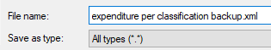

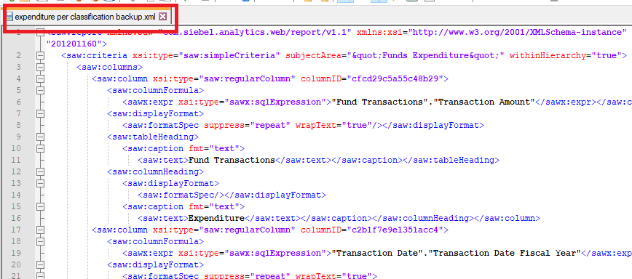

THREE
Create a new report in any subject area and then paste the xml from the above file into the “advanced” tab of the new report.
The new report can be created in any subject area because the xml already contains the subject area “built in”.

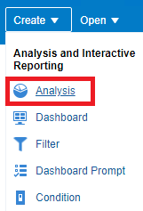

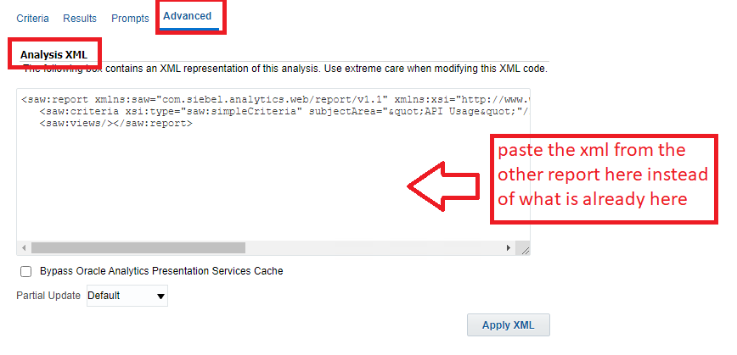

FOUR
After pasting the xml click “Apply XML”

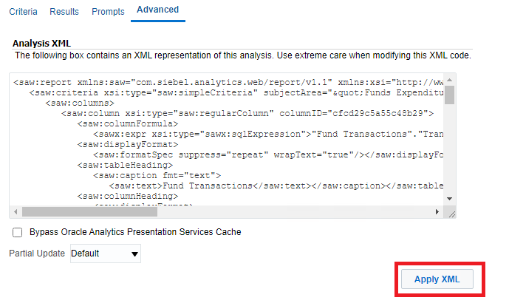

FIVE
Now you have a copy of the original report. You can see this in the “criteria” and the “results” tab.

This is the same criteria as the original report.

